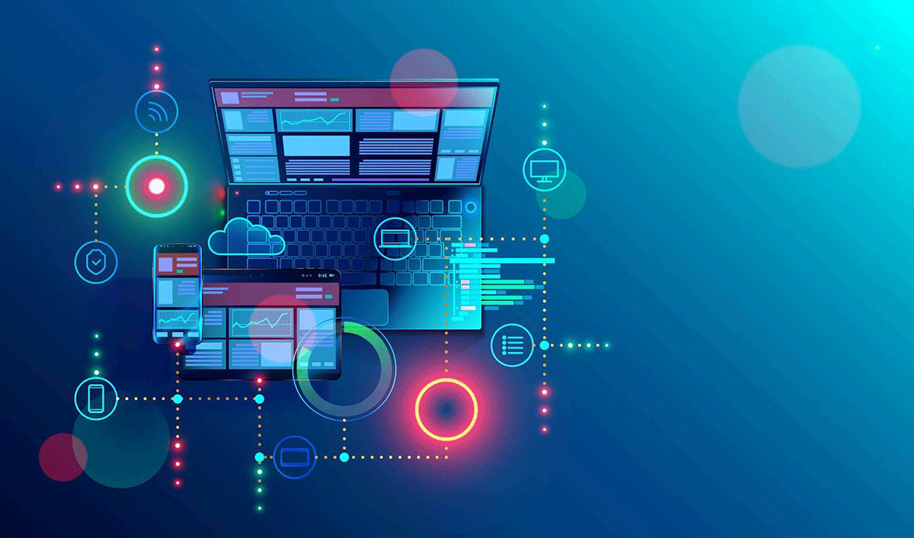

**Software Project Management Plan (SPMP)**

Web.

**Abd alfatah aljuaidi**

**Cover Page**

**Revisions Page**

**Table of Contents**

**TABLE OF CONTENTS**

**1. INTRODUCTION……………………………………………...3**

1.1 Project Overview.…………………………………………3

1.2 Project Deliverable.……………………………………………3

**2. PROJECT ORGANIZATION…………………………………4**

2.1 Software Process Model.…………………………………………4

2.2 Roles and Responsibilities.………………………………………4

2.3 Tools and Techniques……………………………………………4

**3. PROJECT MANAGEMENT PLAN………………………………5**

3.1 Tasks……………………………………………………………………5

3.1.n Task-n………………………………………………………………6

3.1.n.1 Description…………………………………………………7

3.1.n.2 Deliverables and Milestones………………………………………7

3.1.n.3 Resources Needed…………………………………………………7

3.1.n.4 Dependencies and Constraints…………………………………7

3.1.n.5 Risks and Contingencies Assignments……………………8

3.2 Assignments………………………………………………………………9

3.3 Timetable………………………………………………………………9

**4. ADDITIONAL MATERIAL…………………………………10**

**1. INTRODUCTION**

The project's primary goal is to create a user-friendly web platform that allows users to easily build their company's website. The process commences with user registration, where individuals sign up to access the platform's comprehensive features. Upon successful registration, users gain access to a simple and intuitive interface to input their company's specific details and preferences. This information serves as the foundation for the platform's automated website generation system, which swiftly produces a fully customized website in a matter of seconds

* 1. **Project Overview**

The web project aims to provide users with a seamless platform to create their company's website effortlessly. Upon registration, users can input their company's information and preferences, enabling our system to automatically generate website in a matter of seconds.

**User Registration and Authentication:** Users can sign up using their email or social media accounts, ensuring a secure and personalized experience.

**Company Information Input:** Once registered, users can provide essential company details, such as company name, logo, contact information, and a brief description of their products or services.

**Automated Website Generation:** With the provided company information and user preferences, our system automatically generates a fully functional and unique website.

**Mobile Responsiveness:** The generated websites are designed to be responsive, adapting seamlessly to various devices, including desktops, tablets, and smartphones.

**Hosting and Domain Integration:** Users have the option to host their website on our platform and easily integrate their custom domain for a professional online presence.

**User Management:** Registered users can manage and update their websites efficiently through their personalized accounts.

**Target Audience:**

Our platform is tailored for small business owners, startups, entrepreneurs, and individuals seeking a straightforward and efficient means to create a professional website without technical complexities.

**1.2 Project Deliverable**

**User Registration and Authentication System:** Delivery Date: 30th August 2023 Delivery Method: Email Quantity

**User-Friendly Web Platform:** Delivery Date: 15th September 2023 Delivery Method: Online access via URL Quantity: 1 Database for Storing User Information and Website Data: Delivery Date: 15th September 2023 Delivery Method: FTP (File Transfer Protocol) Quantity: 1

**Database for Storing User Information and Website Data:** Delivery Date: 15th September 2023 Delivery Method: FTP (File Transfer Protocol) Quantity: 1

**Pre-designed Website Templates:** Delivery Date: 1st October 2023 Delivery Method: Online access via URL Quantity: 50 templates

**Mobile Responsiveness Module:** Delivery Date: 15th October 2023 Delivery Method: Email Quantity: 1

**SEO Optimization Module:** Delivery Date: 15th October 2023 Delivery Method: Email Quantity: 1

**Hosting and Domain Integration Feature:** Delivery Date: 30th October 2023 Delivery Method: Online access via URL Quantity: 1

**User Management System:** Delivery Date: 30th October 2023 Delivery Method: FTP (File Transfer Protocol) Quantity: 1

**Support and Help Center:** Delivery Date: 15th November 2023 Delivery Method: Online access via URL Quantity: 1

**Documentation and User Guides:** Delivery Date: 15th November 2023 Delivery Method: Email Quantity: 1

**set of comprehensive documentation Training Materials:** Delivery Date: 15th November 2023 Delivery Method: FTP (File Transfer Protocol) Quantity: 1 set of training materials

**2. PROJECT ORGANIZATION**

In this project, we will be adopting the Waterfall model as our chosen development process. The Waterfall model is a linear and sequential approach to software development, where each phase follows a fixed sequence, and progress flows steadily downwards like a waterfall. Here's an overview of how we will apply the Waterfall model to the project:

**Overview of the Waterfall Model:**

**Requirements Gathering:** In this phase, we will collect all the project requirements from clients, stakeholders, and potential users and compile them into a clear and detailed document.

**Analysis:** During this stage, we will analyze the gathered requirements to understand how to implement the project, identify required resources, and create a work schedule.

**Design:** In the design phase, we will design the proposed solution, including defining the system architecture, user interfaces, and technical design details. **Development:** Building upon the technical design, the development phase involves the actual coding and implementation of the entire software product. **Testing & Verification:** Once development is complete, we will move to the testing phase, where we will rigorously test the product to ensure that it meets the specified requirements and works as intended.

**Deployment:** After successful testing and verification, the product will be deployed to the clients or users for actual use.

**Maintenance:** Following deployment, the project will enter the maintenance phase, where we will provide ongoing support, updates, and bug fixes as needed.

**Project Roles and Responsibilities:**

**Project Manager:** Overall project planning and coordination. Resource allocation and scheduling. Monitoring project progress and ensuring adherence to timelines.

**Business Analyst:** Gathering and documenting project requirements. Analyzing and verifying requirements with stakeholders.

**Designers:** Translating requirements into technical design. Creating user interface designs and graphical elements.

**Describe the following items:**

The project web form will be a user interface that allows users to input their company's information and preferences to initiate the website creation process. It will be accessible through common web browsers such as Google Chrome, Firefox, Microsoft Edge, and others. The form will include fields for users to enter their company name, logo, contact information, description of services/products, and customization preferences like color schemes and layout choices. Upon submission, the form data will be processed by the system to generate a customized website.

**Project Milestones:**

**Requirements Gathering and Analysis:**

**Description:** Gather all project requirements from stakeholders and conduct in-depth analysis to ensure a comprehensive understanding of the project scope and objectives. Date: August 15, 2023

**Design and Development Kick-off:**

**Description:** Initiate the design phase and commence development after finalizing the technical design and architecture. Date: September 1, 2023 Completion of

**Web Form Implementation:**

**Description:** Finish developing the project web form, allowing users to input their company information and preferences. Date: September 20, 2023

**2.2 Roles and Responsibilities**

**Project Manager:** Responsible for overall project planning, coordination, and communication with stakeholders. Ensures project goals are achieved within the defined scope, schedule, and budget.

**Business Analyst:** Gathers and documents project requirements. Collaborates with stakeholders to understand their needs and expectations.

**Web Developers:** Responsible for implementing the web form and the automated website generation system. Ensures the platform functions smoothly and efficiently.

|  |  |  |  |
| --- | --- | --- | --- |
| **Team Member** | **Primary Role** | **Secondary** | **Contact Info** |
| **Abd al Fatah** | Project Manager | Developer | [abdalfatah@gmail.com](mailto:abdalfatah@gmail.com)  0797763621 |
| **Abd alfatah** | Quality Assurance | Tester | [abdalfatah@gmail.com](mailto:abdalfatah@gmail.com)  0797763621 |

**2.3 Tools and Techniques**

|  |  |
| --- | --- |
| Tools | Techniques |
| **Project Management Software** | To manage the tasks |
| **Version Control System** | A version control system like Github |
| **Prototyping and Wireframing Tools** | Figma will be used to create interactive prototypes |

**3. PROJECT MANAGEMENT PLAN**

**1. Executive Summary:** The Project Management Plan provides a comprehensive overview of the project's objectives, scope, timelines, resources, and methodologies. It serves as a guiding document for all stakeholders, ensuring a successful and well-executed project.

**2. Project** **Overview:** This section presents a detailed overview of the project, including its purpose, goals, and deliverables. It outlines the project's importance and its alignment with the organization's strategic objectives.

**3. Project Scope:** Clearly defines the boundaries of the project, outlining the specific functionalities, features, and constraints. It ensures a shared understanding of the project's boundaries among all stakeholders.

**4. Project Objectives**: Outlines the specific objectives and success criteria of the project. It establishes measurable goals that contribute to the overall success of the project.

**3.1 Tasks**

**Task-1: Writing and Designing Code using Computer Software Description:** Develop and design website code using programming languages and tools like HTML, CSS, JavaScript, and relevant software development environments. Responsible: Web Developer.

**Task-2:** Create Websites using Programming Languages Description: Utilize programming languages and frameworks to create functional and visually appealing websites according to client requirements. Responsible: Web Developer.

**Task-3:** Data Retrieval Description: Retrieve and fetch data from databases, APIs, or external sources to populate website content dynamically. Responsible: Web Developer.

**3.1.1 Task-1**

**3.1.1.1 Description**

**Understanding Requirements:** The web developers will thoroughly review the technical design, wireframes, and project requirements to gain a comprehensive understanding of the website's functionalities, features, and design elements.

**Selecting Development Tools:** Based on the project's requirements and the team's expertise, the developers will choose appropriate computer software, integrated development environments (IDEs), and text editors to facilitate coding efficiently.

**Front-end Development:** Front-end developers will start by writing code in HTML to create the website's structure and content. They will then use CSS to style the elements, defining colors, typography, layout, and responsive design for different devices.

**3.1.1.2 Deliverables and Milestones**

**Deliverables:**

**Front-end Code:** Deliver HTML, CSS, and JavaScript files that define the website's user interface, layout, and interactivity. The front-end code should be responsive and compatible with various devices and browsers.

**Back-end Code:** Provide server-side code written in the chosen programming language (e.g., Python, Ruby, Java, PHP) that handles data processing, business logic, and database interactions.

**Integrated** **Codebase:** Merge front-end and back-end code into an integrated codebase that seamlessly interacts to create a fully functional

**Milestones:**

**Milestone 1** -

**Front-end Development (Week 2):** Completion of HTML, CSS, and initial JavaScript code for the website's front-end. Basic layout and design elements are ready for review. Milestone

**2 - Back-end Development (Week 4):** Completion of server-side code to handle database connections and basic data processing. Initial back-end functionality is ready for integration. Milestone

**3 - Code Integration (Week 6):** Successful integration of front-end and back-end code into a functional website. Initial testing of the integrated code is performed.

**3.1.1.3 Resources Needed**

Open Solution Explorer and Select Web Resources Description: Access the project's Solution Explorer, a tool used in development environments like Visual Studio. In the Solution Explorer, locate and select the "Web Resources" section. 2. Choose Web Resources under Components Description: Within the Web Resources section, identify and choose the "Web Resources" category, which contains all the resources needed for web development. 3. Create a New Web Resource Description: To add a new web resource to the project, select the "New" option. This will prompt the creation of a new web resource file where you can add your resource data

**3.1.n.4 Dependencies and Constraints**

**Dependencies**

**Design Approval:** The development process depends on obtaining design approval from the client or stakeholders. Before writing and designing the code, the finalized design and layout must be available to ensure accurate implementation.

**Requirements Completion:** The coding process depends on having clear and complete project requirements. Any ambiguities or gaps in requirements can lead to delays or incorrect implementations.

**Constraints:**

**Time Constraint:**

The project may have a specific deadline or time constraint that limits the development period. This can impact the scope of work and the amount of code that can be written and designed. Budget

**Limitations:**

Budget constraints may limit the resources and tools available for coding, potentially affecting the choice of programming languages or software used.

**3.1.1.5 Risks and Contingencies Assignments**

**Risk: Code Defects and Bugs**

**Description:** Coding errors or bugs might be identified during testing, impacting the functionality and quality of the website.

**Contingency:** The development team will follow a rigorous testing process, including unit tests and continuous integration, to detect and resolve defects early on. They will establish a bug tracking system and allocate sufficient time for debugging and fixing issues.

**3.2 Assignments**

**Front-end Developer:** Responsible for writing HTML, CSS, and JavaScript code to create the website's user interface and layout. Ensures the website is visually appealing, responsive, and compatible with various devices and browsers. Collaborates with designers to implement the approved design.

**Back-end Developer:** In charge of writing server-side code using the chosen programming language (e.g., Python, Ruby, Java, PHP). Handles data processing, business logic, and database interactions to make the website functional. Works closely with the front-end developer to integrate front-end and back-end components.

**3.3 time table**

****Week 1-2: Project Initiation and Requirements Gathering****

* Task 1: Define project scope, objectives, and stakeholders.
* Task 2: Conduct interviews and workshops to gather requirements.
* Task 3: Create a detailed project plan and allocate resources.

****Week 3-4: Design Phase****

* Task 4: Create wireframes and mockups for website design.
* Task 5: Finalize the technical design and architecture.

****Week 5-8: Front-end and Back-end Development****

* Task 6: Front-end development - HTML, CSS, and JavaScript.
* Task 7: Back-end development - Server-side code and database integration.
* Task 8: Integration of front-end and back-end components.

**4. ADDITIONAL MATERIAL**

**Startup Plan:** A detailed plan outlining the initial steps to set up the project, including project kick-off, team onboarding, and resource allocation.

**Content and Asset Delivery Plan:** A plan specifying the schedule and method of delivering content, images, videos, and other assets needed for website development. It ensures that the necessary materials are available to the development team on time.